2nd Assignment Day 5 | 4th December 2020

Question

1. Add a 10GB disk to the CentOS.

2. Create 2 Partitions 4GB and 6GB of Space respectively.

3. Format 4GB with xfs and 6GB with ext4 file system.

4. Mount 4GB and 6GB in /data and /music directory respectively.

5. Create one file of 1GB in each of the mount point created above.

6. Verify the disk Consumption and disk space free in the mounted partitions.

Answer

1. Add a 10GB disk to the CentOS.

Verify That Disk Is Added Using **fdisk -l**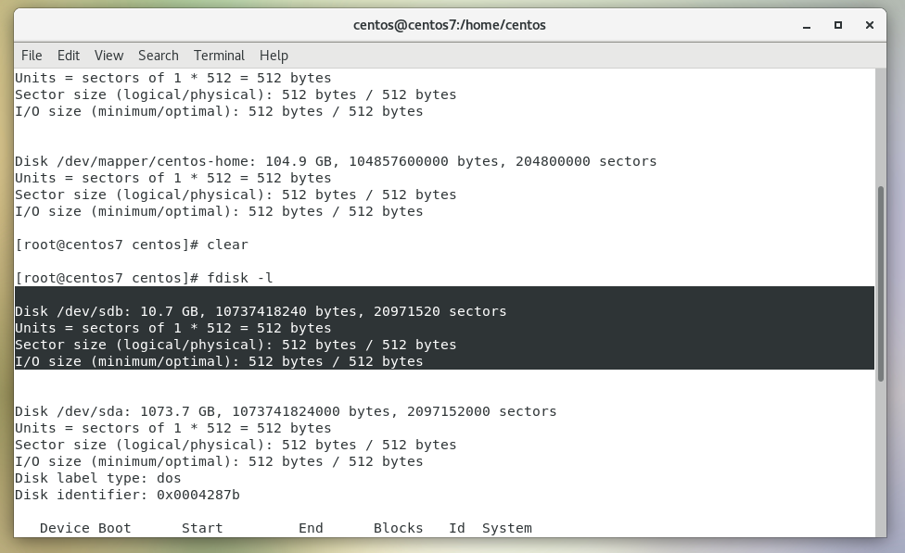

1. Create 2 Partitions 4GB and 6GB of Space respectively.

Create 2 Partitions

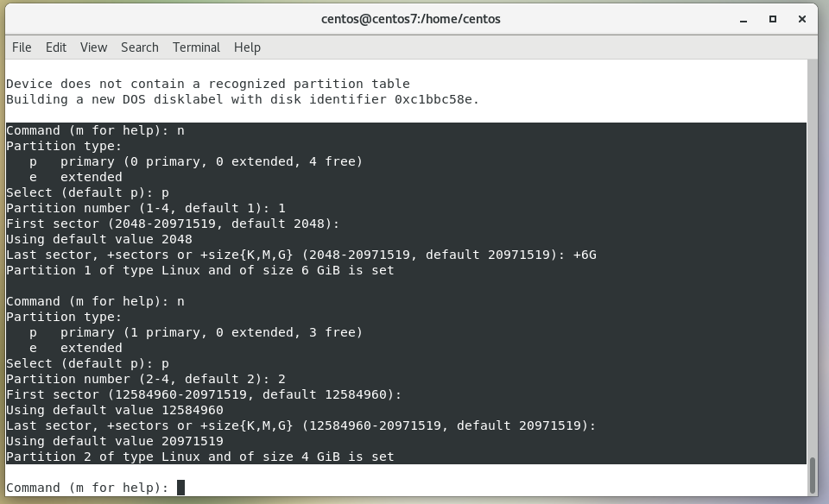

3. Format 4GB with xfs and 6GB with ext4 file system.

Formating And Creating File System Using **mkfs** Command

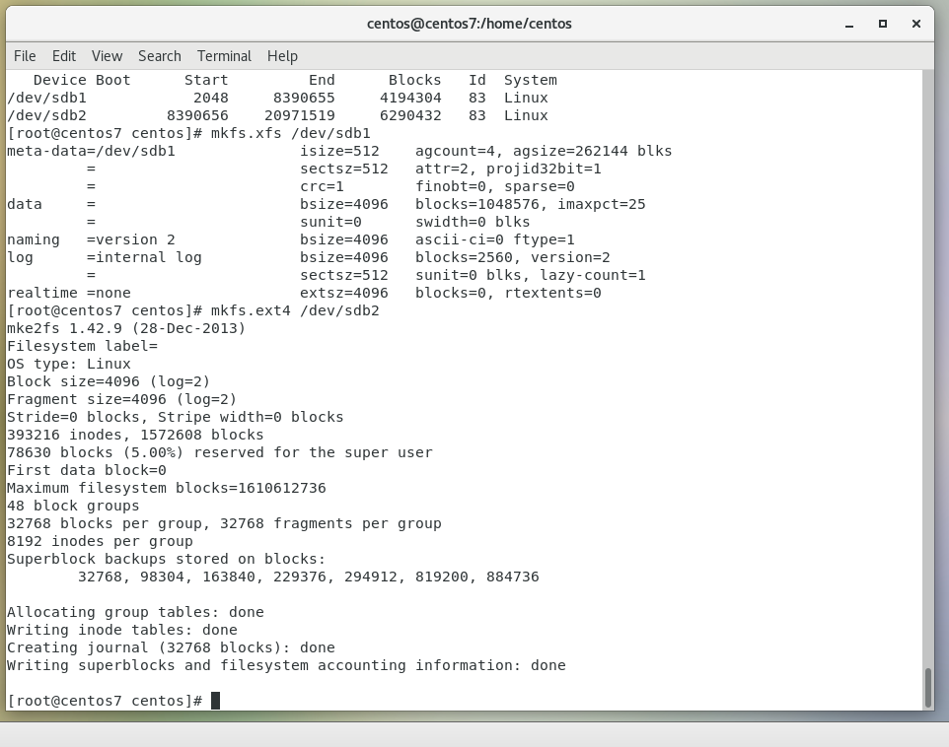

4. Mount 4GB and 6GB in /data and /music directory respectively.

Creating Mount Point Using **fstab** File

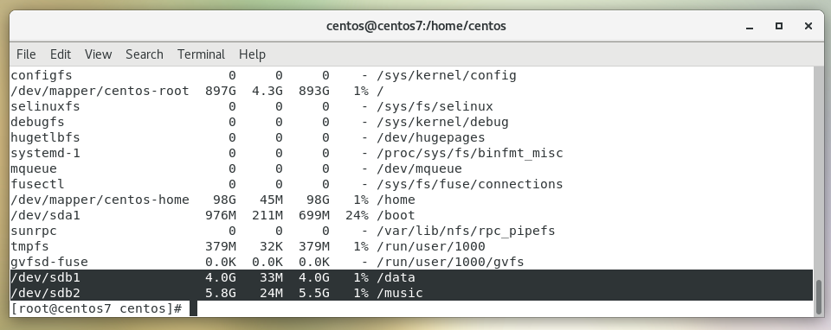

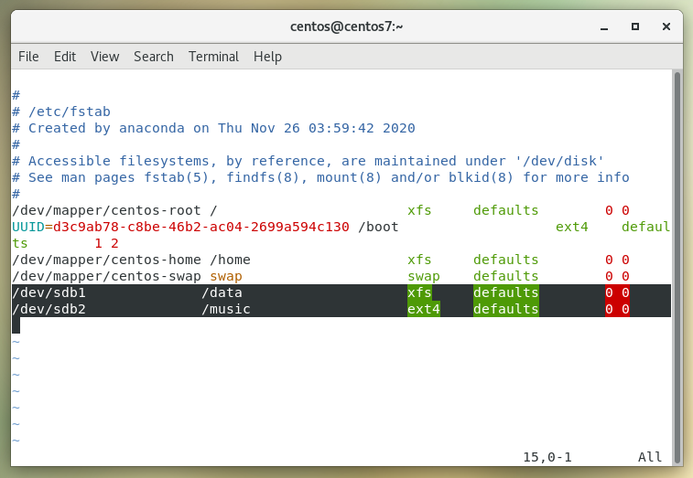

5. Create one file of 1GB in each of the mount point created above.

Creating 1Gb File Using **seq 1000000 >** Command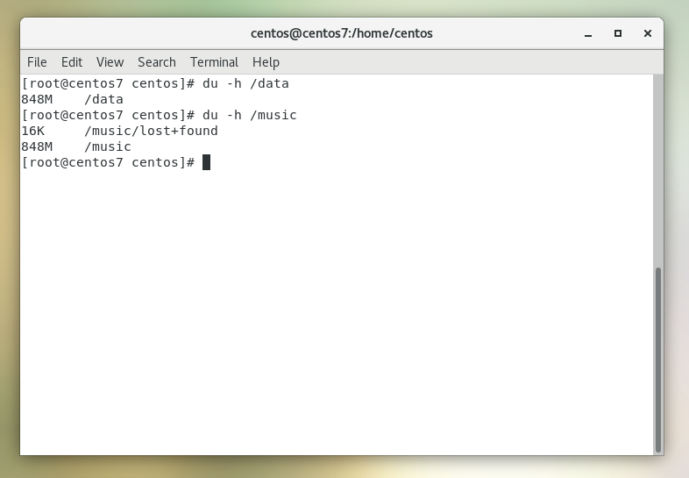

6. Verify the disk Consumption and disk space free in the mounted partitions

Verify Disk Usage Using **df -h** Command

